**MBAN 5220 Assignment 2**

**Chapter 4 Level I and II Exercises (Continued)**

4 a)

**data** sales_staff2;

infile "&path\sales2.dat";

input @**1** Employee_ID **6.**

@**21** Last_Name $18. /

@**1** Job_Title $20.

@**22** Hire_Date mmddyy10.

@**33** Salary dollar8. /;

**run**;

b)

title 'Australian and US Sales Staff';

**proc** **print** data = sales_staff2 noobs;

**run**;

title;

13 title 'Australian and US Sales Staff';

14

15 proc print data=sales_staff2 noobs;

NOTE: Writing HTML Body file: sashtml.htm

16 run;

NOTE: There were 165 observations read from the data set WORK.SALES_STAFF2.

NOTE: PROCEDURE PRINT used (Total process time):

real time 1.07 seconds

cpu time 0.18 seconds

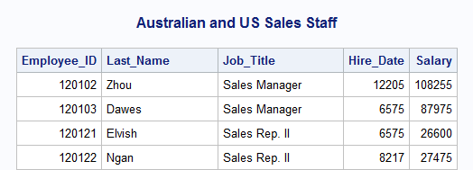

5 a)

**data** AU_sales US_sales;

drop Country;

infile "&path\sales3.dat";

input @**1** Employee_ID **6.**

@**21** Last_Name $18.

@**43** Job_Title $20.;

input @**10** Country $2. @;

if Country = 'AU' then do;

input @**1** Salary dollarx8.

@**24** Hire_Date ddmmyy10.;

output AU_sales;

end;

else if Country = 'US' then do;

input @**1** Salary dollar8.

@**24** Hire_Date mmddyy10.;

output US_sales;

end;

**run**;

b)

title 'Australian Sales Staff';

**proc** **print** data=AU_sales noobs;

**run**;

title 'US Sales Staff';

**proc** **print** data=US_sales noobs;

**run**;

title;

42 title 'Australian Sales Staff';

43 proc print data=AU_sales noobs;

44 run;

NOTE: There were 63 observations read from the data set WORK.AU_SALES.

NOTE: PROCEDURE PRINT used (Total process time):

real time 0.04 seconds

cpu time 0.03 seconds

45

46 title 'US Sales Staff';

47 proc print data=US_sales noobs;

48 run;

NOTE: There were 102 observations read from the data set WORK.US_SALES.

NOTE: PROCEDURE PRINT used (Total process time):

real time 0.06 seconds

cpu time 0.06 seconds

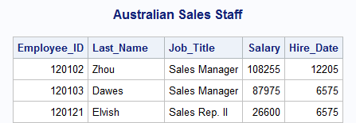

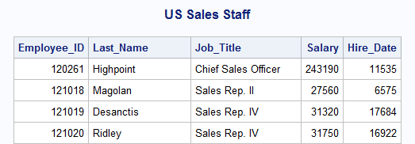

**Chapter 5 Level I and II Exercises**

1 a)

**data** work.codes;

set orion.au_salesforce;

length FCode1 FCode2 $ **1** LCode $ **4**;

FCode1 = lowcase(substr(First_Name, **1**, **1**));

FCode2 = substr(First_Name, length(First_Name), **1**);

LCode = lowcase(substr(Last_Name, **1**, **4**));

**run**;

b)

title 'Extracted Letters for User IDs';

**proc** **print** data = work.codes;

var First_Name FCode1 FCode2 Last_Name LCode;

**run**;

title;

NOTE: There were 63 observations read from the data set WORK.CODES.

NOTE: PROCEDURE PRINT used (Total process time):

real time 0.43 seconds

cpu time 0.10 seconds

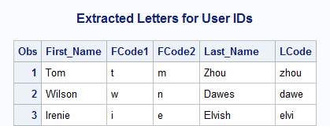

2 a)

**data** work.small;

set orion.newcompetitors;

Country = substr(ID, **1**, **2**);

Store_Code = left(substr(ID, **3**));

if substr(Store_Code, **1**, **1**) = '1';

City = propcase(City);

**run**;

NOTE: There were 7 observations read from the data set ORION.NEWCOMPETITORS.

NOTE: The data set WORK.SMALL has 5 observations and 5 variables.

NOTE: DATA statement used (Total process time):

real time 0.06 seconds

cpu time 0.01 seconds

b)

title 'New Small-Store Competitors';

**proc** **print** data = work.small noobs;

var Store_Code Country City Postal_Code;

**run**;

title;

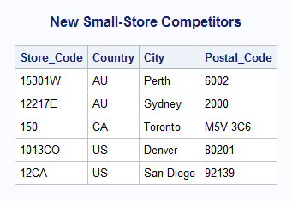

4 a)

**data** names;

length New_Name $**50**

FMnames $**30**

Last $**30**;

set orion.customers_ex5;

FMnames = scan(Name, **2**, ',');

Last = propcase(scan(Name, **1**, ','));

if Gender = "F" then New_Name = CATX(' ', 'Ms.', FMNames, Last);

else if Gender = "M" then New_Name = CATX(' ', 'Mr.', FMNames, Last);

keep New_Name Name Gender;

**run**;

b) c)

**proc** **print** data = names;

**run**;

NOTE: There were 77 observations read from the data set WORK.NAMES.

NOTE: PROCEDURE PRINT used (Total process time):

real time 0.04 seconds

cpu time 0.03 seconds

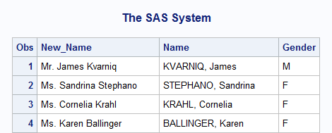

5 a)

**data** work.silver work.gold work.platinum;

set orion.customers_ex5;

Customer_ID = tranwrd(Customer_ID, '-00-', '-15-');

if find(Customer_ID, 'Silver', 'I') > **0** then

output work.silver;

else if find(Customer_ID, 'Gold', 'I') > **0** then

output work.gold;

else if find(Customer_ID, 'Platinum', 'I') > **0** then

output work.platinum;

keep Name Customer_ID Country;

**run**;

5 b) c)

title 'Silver-Level Customers';

**proc** **print** data = work.silver noobs;

**run**;

title 'Gold-Level Customers';

**proc** **print** data = work.gold noobs;

**run**;

title 'Platinum-Level Customers';

**proc** **print** data = work.platinum noobs;

**run**;

title;

NOTE: There were 17 observations read from the data set WORK.SILVER.

NOTE: PROCEDURE PRINT used (Total process time):

real time 0.42 seconds

cpu time 0.15 seconds

NOTE: There were 2 observations read from the data set WORK.GOLD.

NOTE: PROCEDURE PRINT used (Total process time):

real time 0.03 seconds

cpu time 0.00 seconds

NOTE: There were 5 observations read from the data set WORK.PLATINUM.

NOTE: PROCEDURE PRINT used (Total process time):

real time 0.03 seconds

cpu time 0.03 seconds

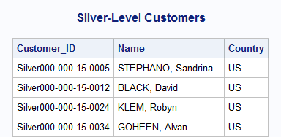

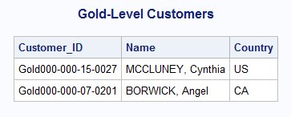

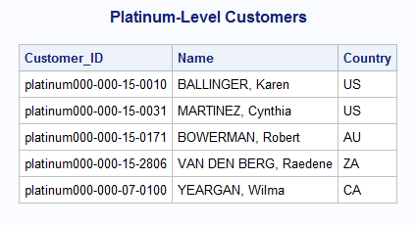

6 a)

**data** work.split;

set orion.employee_donations (obs = **10**);

PctLoc = find(Recipients, '%');

if PctLoc > **0** then do;

Charity = substr(Recipients, **1**, PctLoc);

output;

Charity = substr(Recipients, PctLoc + **3**);

output;

end;

else do;

Charity = trim(Recipients)!! ' 100%';

output;

end;

drop PctLoc Recipients;

**run**;

**proc** **print** data = work.split noobs;

var Employee_ID Charity;

**run**;

NOTE: There were 10 observations read from the data set

ORION.EMPLOYEE_DONATIONS.

NOTE: The data set WORK.SPLIT has 18 observations and 7 variables.

NOTE: DATA statement used (Total process time):

real time 0.01 seconds

cpu time 0.00 seconds

b)

**data** work.split;

set orion.employee_donations;

PctLoc = find(Recipients, '%');

if PctLoc > **0** then do;

Charity = substr(Recipients, **1**, PctLoc);

output;

Charity = substr(Recipients, PctLoc + **3**);

output;

end;

else do;

Charity = trim(Recipients)!! ' 100%';

output;

end;

drop PctLoc Recipients;

**run**;

title 'Charity Contributions for each Employee';

**proc** **print** data = work.split noobs;

var Employee_ID Charity;

**run**;

title;

NOTE: There were 212 observations read from the data set WORK.SPLIT.

NOTE: PROCEDURE PRINT used (Total process time):

real time 0.56 seconds

cpu time 0.12 seconds

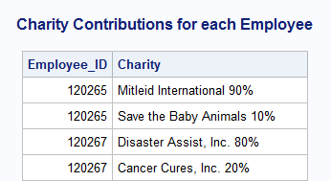

8 a)

**data** work.sale_stats;

set orion.orders_midyear;

MonthAvg = round(mean(of month1-month6));

MonthMax = max(of month1-month6);

MonthSum = sum(of month1-month6);

**run**;

NOTE: There were 24 observations read from the data set ORION.ORDERS_MIDYEAR.

NOTE: The data set WORK.SALE_STATS has 24 observations and 10 variables.

NOTE: DATA statement used (Total process time):

real time 0.02 seconds

cpu time 0.00 seconds

8 b)

title 'Statistics on Monthes in which the Customer Placed an Order';

**proc** **print** data = work.sale_stats noobs;

var Customer_ID MonthAvg MonthMax MonthSum;

**run**;

title;

185 title 'Statistics on Monthes in which the Customer Placed an Order';

186 proc print data = work.sale_stats noobs;

NOTE: Writing HTML Body file: sashtml4.htm

187 var Customer_ID MonthAvg MonthMax MonthSum;

188 run;

NOTE: There were 24 observations read from the data set WORK.SALE_STATS.

NOTE: PROCEDURE PRINT used (Total process time):

real time 0.41 seconds

cpu time 0.15 seconds

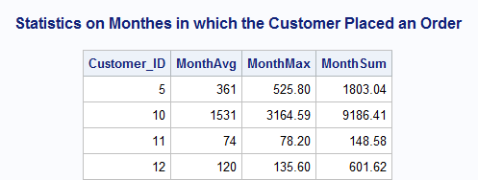

10 a) b)

Product_ID=220101400088 Ship_Date=28FEB2011 Quantity=5 Price=$17.50

Comment=Shipped on 18686 Total=. _ERROR_=1 _N_=19

NOTE: Invalid numeric data, Price='$21.95' , at line 195 column 22.

WARNING: Limit set by ERRORS= option reached. Further errors of this type

will not be printed.

Product_ID=240700400017 Ship_Date=09MAR2011 Quantity=1 Price=$21.95

Comment=Shipped on 18695 Total=. _ERROR_=1 _N_=20

NOTE: Missing values were generated as a result of performing an operation

on missing values.

Each place is given by: (Number of times) at (Line):(Column).

148 at 195:20

NOTE: There were 148 observations read from the data set ORION.SHIPPED.

NOTE: The data set WORK.SHIPPING_NOTES has 148 observations and 6 variables.

NOTE: DATA statement used (Total process time):

real time 0.04 seconds

cpu time 0.03 seconds

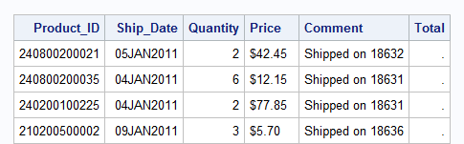

10 c)

**data** shipping_notes;

set orion.shipped;

length Comment $ **21**;

Comment = cat('Shipped on ', put(Ship_Date, mmddyy10.));

Total = Quantity * input(Price, comma7.);

**run**;

**proc** **print** data = shipping_notes noobs;

format Total dollar7.2;

**run**;

NOTE: There were 148 observations read from the data set WORK.SHIPPING_NOTES.

NOTE: PROCEDURE PRINT used (Total process time):

real time 0.43 seconds

cpu time 0.18 seconds

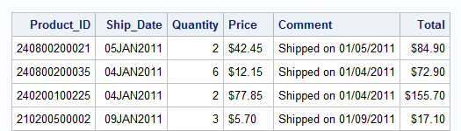

11 a)

**data** US_converted;

keep ID Telephone Birthday;

set orion.US_newhire (rename =

(ID = cID

Telephone = nTelephone

Birthday = cBirthday));

ID = input(compress(cID, '-'), **15.**);

length Telephone $ **8**;

Telephone = cat(substr(put(nTelephone, **7.**), **1**, **3**),

'-', substr(put(nTelephone, **7.**), **4**));

Birthday = input(cBirthday, date9.);

**run**;

11 b)

title 'US New Hires';

**proc** **print** data = US_converted noobs;

**run**;

title;

**proc** **contents** data = US_converted varnum;

**run**;

NOTE: There were 10 observations read from the data set WORK.US_CONVERTED.

NOTE: PROCEDURE PRINT used (Total process time):

real time 0.40 seconds

cpu time 0.14 seconds

